Portland Sea Dogs
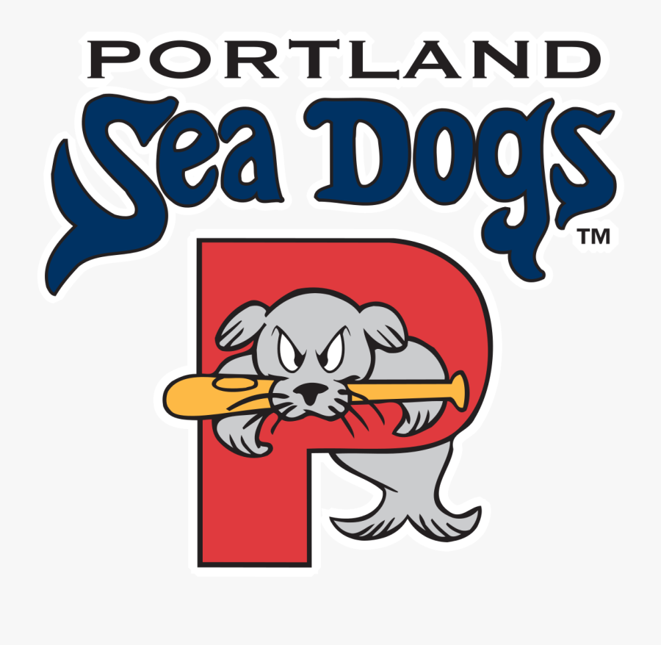

Report By: Thomas Hesse

OVERVIEW

General:

Description: The Portland Sea Dogs are a Double-A Minor League Baseball team based in Portland, Maine, affiliated with the Boston Red Sox. Since 1994, they’ve combined player development with community-focused entertainment, offering affordable, family-friendly experiences at Hadlock Field. Their fan base includes families, young athletes, and lifelong baseball enthusiasts across New England.

Mission Statement: To bring life to the lives of Main residents through baseball, community engagement, and accessible entertainment.

Vision Statement: To be Portland’s heartbeat for cultural and athletic connection—where baseball sparks joy, growth, and lifelong community.

Core Values:
- Community First – Supporting local causes and building strong relationships
- Inclusive Fun – Creating welcoming, memorable experiences for all ages
- Player Growth – Helping athletes reach their full potential
- Affordability & Access – Keeping games and events budget-friendly and easy to enjoy

Brand Strengths and Opportunities:
Strengths- Strong Red Sox affiliation, trusted community presence, unique gameday experience, and consistent fan engagement and promotions.
Opportunities- Expand digital content, reach younger more diverse audiences, build new partnerships with local organizations, and develop more interactive youth programs.

Personnel

CEO/Executive Director:
- Geoff Iacuessa – President & General Manager
- Jesse Scaglion – General Manager
- Jim Heffley – VP of Financial & Game Operations

Coaching Staff:
- Manager – Chad Epperson
- Pitching Coach – Bob Kipper
- Hitting Coach – Doug Clark
- Bench Coach – Joe Oliver

High-Profile Players and Employees:
- Blaze Jordan (1st Baseman)
- Mikey Romero (3rd Baseman)
- Allan Castro (Centerfielder)
- Max Ferguson (2nd Baseman)

Publics
Key Publics: Public Group (TYPE)- Role
- Fans and Ticket Holders (Diffused) – General public who attend games and engage with promotions
- Boston Red Sox (Enabling) – provides players, resources, and brand affiliation
- Minor League (Functional) – Governing body overseeing operations and standards
- Local Businesses and Sponsors (Normative) – Partner with the team for marketing and outreach
- Media Outlets (Enabling) – Share team news, promote events, and build visibility
- Community Organizations (Normative) – Collaborate on charitable and educational initiatives
- Sea Dogs Front Office Staff (Functional) – Operate day to day business and fan engagement
- Players and Coaching Staff (Functional) – Deliver on field performance and community presence
League, Governing Body, and Association Affiliation:
- Eastern League
- Major League Baseball (MLB)
- Minor League Baseball (MiLB)
- National Association of Professional Baseball Leagues (NAPBL)
- Professional Baseball Athletic Trainers Society (PBATS)
- Red Sox Player Development System
- United States Baseball Federation (USBF)
- Women in Sports and Events (WISE) – via staff affiliations

Media Outlets / Contacts:
- Maine Public Radio (News Desk)
- Portland Press Hearld (Kevin Thomas (sports editor))
- Sea Dogs Media Guide (Emma Tiedemann (Broadcasting Director))
- WCSH 6 (CBS Portland) (Sports Team)
- WGME 13 (CBS Portland) (Jeff Peterson)
- WMTW 8 (ABC Portland) (Travis Lee)
- WLOB Radio (Ray Richardson)

Community Partners:
- Barbara Bush Children’s Hospital
- Delta Dental
- Good Shepherd Food Bank
- MaineHealth
- Make-A-Wish Maine
- Porland Parks & Recreation
- United Way of Southern Maine
- University of Southern Maine

